HADLOW DOWN COMMUNITY CENTRE (HDCC) BUSINESS PLAN
Updated December 2025

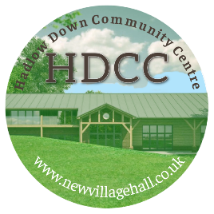

www.newvillagehall.co.uk |www.facebook.com/HadlowDownCommunityCentre

CONTENTS

Part 1 Executive Summary
Part 2 Organisation and hall background
Part 3 Objective/Aim/Mission
Part 4 Current Status
Part 5 Community Need
Part 6 The Future
Part 7 Finance
Part 8 Management Organisation
Part 9 Marketing
Part 10 Environmental Impact
Part 11 Monitoring and Evaluation
Part 12 Action Plan
Part 13 Summary

PART 1 EXECUTIVE SUMMARY

The Hadlow Down Community Centre (HDCC) project will create a modern, fully accessible, environmentally sustainable community hub to replace two obsolete buildings that are no longer fit for purpose. This project has been developed in direct response to clear, evidenced community need and meets multiple strategic priorities for rural inclusion, health and wellbeing, active lifestyles, community resilience, environmental sustainability and social cohesion. The existing Village Hall and Sports Pavilion cannot meet modern accessibility, safeguarding, environmental or sporting standards. Without intervention, the community faces the loss of essential social and recreational infrastructure.
HDCC is a registered Charitable Incorporated Organisation with a 99-year lease on the site, ensuring long-term security for investment. The project is fully planning-approved, technically ready, and supported by a strengthened governance model involving HDCC trustees, the Hadlow Down Playing Field Association, and the Parish Council. This provides transparent oversight, robust risk management and strong local accountability—critical factors for funders of major capital projects.
The compelling support for the new centre is demonstrated through extensive consultation: 83% of residents support the development, while a formal Parish Poll (2025) confirmed the community’s willingness to contribute through both asset disposal of the existing hall (estimated at £250k) and a public loans board application (£250k). We are currently pursuing match funding from the Community Infrastructure Levy from Wealden District Council.
The proposed centre will enable a step-change in service provision. It will deliver a multi-purpose hall, meeting rooms, modern changing facilities, a club room, and a community café, alongside safe parking and improved pedestrian access. These facilities will support a wide range of activities—including arts, theatre, indoor sport, children’s programmes, adult education, wellbeing and fitness, youth activities and intergenerational events—expanding participation across all age groups, including older residents, disabled people and families with young children. The centre will also strengthen the viability of local sports provision and provide a much-needed resource for surrounding rural parishes lacking suitable facilities. We have phased the development in 2 parts. Phase 1 is for the main body of the community centre and Phase 2 will add the sports pavilion elements with changing rooms and a sports bar. The cost of the development is estimated at £2.3M for Phase 1 and £0.9M for Phase 2. Although part of the Phase 2 build costs will be covered by a VAT rebate of £440k on Phase 1.
Environmental sustainability is integral to the design. The centre will incorporate low-carbon heating, high-performance insulation, on-site renewable energy, sustainable drainage and biodiversity improvements. This aligns strongly with Wealden District Council’s Climate Emergency commitments and national priorities for decarbonising community infrastructure.
The new community centre will be financially robust. Benchmarking with comparable halls and detailed modelling show the centre will achieve break-even or small surplus from Year 2, rising steadily thereafter. Income will derive from hire fees, programmed activities, workspace use and the volunteer-run café; all surpluses will be reinvested into operations, maintenance and community projects. A phased fundraising strategy is in place, supported by a professional fundraiser, targeting grant makers whose priorities align with rural development, health and wellbeing, inclusion, sport, arts and environmental sustainability.
Construction is planned to begin in 2027, subject to funding, with completion in 2028 and full community operation in 2029. The project is deliverable, strategically aligned, community-backed and financially sustainable.
With funder support, Hadlow Down will secure a resilient, inclusive and future-proofed community asset that will generate measurable social, environmental and economic impact for decades to come.

PART 2 ORGANISATION AND HALL BACKGROUND

- The Organisation
Hadlow Down Community Centre (HDCC) is a registered Charitable Incorporated Organisation (CIO), with the clear objective of delivering a modern, multi-use community hub at the heart of Hadlow Down. The new centre will replace the ageing Village Hall and Cricket Pavilion with a single, fully accessible, environmentally responsible facility situated on the Hadlow Down Playing Field.
Our purpose is to provide a flexible, future-proof space that meets the needs of residents of all ages—supporting sports, recreation, education, business use, wellbeing activities, and social events. Developed collaboratively with the Parish Council, local user groups, and residents, the project is designed to strengthen community cohesion while ensuring long-term stewardship of this essential rural asset.
HDCC operates as CIO No. 1158375, with a registered address at C/O Ailsa, Waghorns Lane, Hadlow Down TN22 4JA. The charity is governed by 6 trustees, supported by 3 committee members and a volunteer base of approximately 20 local residents, ensuring strong community representation and operational resilience.

- The Lease
HDCC has secured a 99-year lease from Hadlow Down Parish Council for the car park and the footprint of the new community centre—providing long-term security for capital investment and future growth.
The centre will operate in coordinated partnership with the Hadlow Down Playing Field Association (Charity No. 270069), which holds the lease for the remainder of the playing field and the football pitch. This collaborative model ensures effective joint management of the wider site and protection of long-term community use.
(Full lease documentation is included in the appendix.)

- Planning and Building Control
The project benefits from full planning and technical approvals already in place:
- Planning Permission Granted: 2019 – Reference WD/2018/2655/MAJ
- Extant Planning Permission Confirmed: June 2024 – WD/2024/0658/CD
- Building Regulations Approval (Drainage): June 2024 – Ref F2450104
- Approval of Conditions: Conditions 3, 4, 5, 6, 7, 9, 15 and 16 attached to WD/2018/2655/MAJ were formally approved in 2024 and are available on the planning portal.
Copies of all approvals are provided within the supporting documents.
These consents ensure the project is fully compliant and immediately ready for construction, strengthening fundability and demonstrating a robust delivery trajectory.
- Location and Catchment
The new HDCC will serve Hadlow Down’s core population of 820 residents, while also functioning as a vital hub for neighbouring rural communities. The village’s strategic position on the A272 unlocks access to a significantly wider catchment and positions the centre as a bridge between rural and urban populations. Given we have a very limited public transport service in Hadlow Down, for those without access to their own transport, the community centre will provide crucial accessible facilities.
Key locational advantages include:
- Proximity to expanding towns:
  - Uckfield and Maresfield are experiencing rapid residential development and increased demand for community services.
  - Crowborough, one of the region’s largest towns, offers additional potential users seeking a rural alternative for events, activities, and wellbeing services.
- Rural community access:
Residents from Buxted, Blackboys, Five Ashes, and Rotherfield will benefit from improved access to essential facilities without travelling to larger towns.
- Transport Connectivity:
  - Direct access via the A272 encourages regional participation.
  - Links to the A26 (north–south) and A267 (coastal route) further expand the potential catchment across East Sussex.
This strategic location supports HDCC’s role as a high-impact rural centre, increasing participation, enabling sustainable operating income, and providing vital services to dispersed populations.
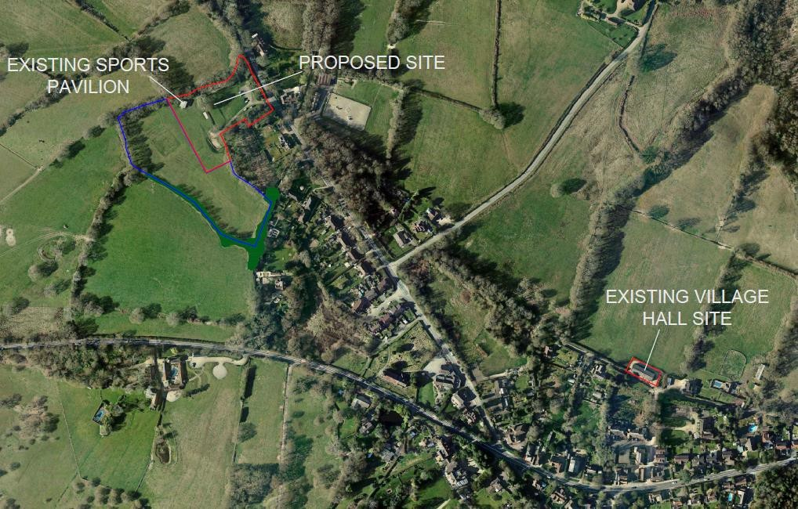
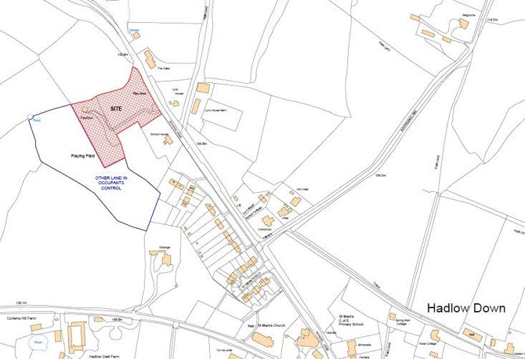

PART 3 OBJECTIVE / KEY PRINCIPLES

Our Objective is to create a modern, accessible, and sustainable facility that meets the social, recreational, sporting, and health and wellbeing needs of residents, now and for future generations.

The new centre will provide a much-needed focal point for Hadlow Down and the surrounding rural area—a place where people of all ages can socialise, exercise, learn, and celebrate. It will strengthen community cohesion, reduce isolation, encourage active lifestyles, support local sports participation, and provide high-quality, accessible facilities for groups, clubs, and families. It will also offer a sustainable venue for cultural, educational, and social activities.

The proposed centre will combine a new village hall and sports pavilion in a single, efficient design, creating a true community hub. Key design features include:
Dual-purpose layout: Integrating the village hall and sports pavilion to maximise use and reduce operating costs.
Versatile spaces: A large main hall, flexible meeting rooms, modern changing facilities, and a clubroom to support varied community activities.
Sustainability: Energy-efficient construction and low-maintenance materials to ensure long-term environmental and financial viability.

Key Principles
- A village centre Hadlow Down can be proud of, with facilities appropriate for the 21st Century with an economical, low maintenance and eco-friendly building.
- An accessible community hub to promote cohesion within our community and tackle the issue of isolation and loneliness which has been exacerbated since the pandemic.
- Flexible spaces designed for good circulation and choice of rooms for simultaneous events.
- Suitable space for casual sport, e.g., short mat bowls, table tennis, exercise classes
- Modern kitchen and catering facilities
- Facilities for older residents and those with disabilities and young children
- Adequate storage
- Improved and enlarged car park and safe pedestrian access.
- Reducing reliance on cars, fostering local economy, thereby bridging the gap left by absent public transport and empowering residents who can’t drive.

The project has strong local support, demonstrated through extensive community consultation and active volunteer involvement. It aligns with district priorities for wellbeing, rural inclusion, and community resilience. With planning permission secured, a proven delivery track record, and committed community backing, we are now seeking grant funding to complete the final stage of this transformative project.

PART 4 CURRENT STATUS

- Current Community Facilities
The existing Village Hall and Sports Pavilion in Hadlow Down are approaching the end of their functional lifespans. While both buildings continue to serve the community, their limitations significantly restrict future use, operational efficiency, and the ability to meet modern standards.
- Village Hall:
The current hall remains in regular use; however, its ageing structure and lack of modern, extended facilities constrain its potential. Ongoing refurbishment efforts can no longer overcome fundamental issues relating to building footprint, insufficient car parking, and inadequate access for elderly and disabled residents. These structural limitations strongly support the case for a new, purpose-built community facility at an improved location.
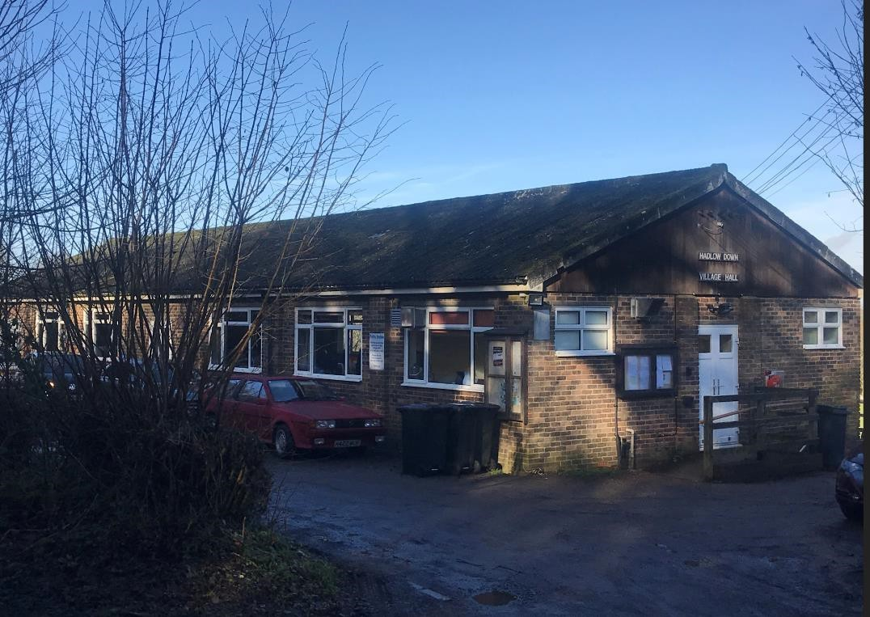
- Cricket Pavilion:
The pavilion is in a poor state of repair and accessible only via steps, creating barriers for many users. Although it currently accommodates football, cricket, and informal recreational activities, its outdated changing rooms, toilets, and shower facilities significantly limit its usability and the opportunities for expanded sports participation.
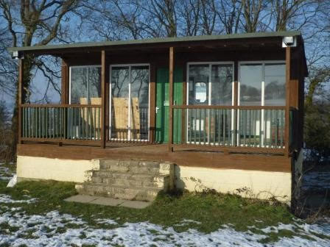
Despite these challenges, both buildings continue to play valued roles as community gathering spaces, providing venues for recreation, social engagement, and local events. Demand for community space remains strong, and findings from the most recent village survey demonstrate that usage would increase substantially with improved, modern facilities.
A range of village groups are currently based at the existing hall, including the Amateur Dramatic Society, Line Dancing and ballet classes, The hall also hosts the weekly TN22 Club for residents over 60. Similarly, the cricket pavilion continues to support sports clubs and is also used periodically for pop-up dinners and small committee meetings.

- Evolution of the Plans
The development of the new Hadlow Down Community Centre has progressed through a structured and well-documented process over many years:
- Initial Exploration (2008–2010): - Hadlow Down Parish Council began investigating the need for a replacement community centre in 2008. A working group was established in 2010 to take forward the project and assess viable options.
- Early Options Considered: Initial proposals focused on extending or rebuilding on the existing Village Hall site under Permitted Development Rights. However, this approach was deemed unfeasible due to restrictions on development, the unadopted status of Hut Lane, poor emergency vehicle access, and limited parking capacity.
- Shift to a Combined Facility on the Playing Field: - A preferred option emerged to construct a single, integrated sports and community centre on the village playing fields. Public consultation in 2011 demonstrated strong community support and helped define the types of facilities most needed by residents.
- Planning and Business Planning (2014–2017): - Following an extensive planning period, outline planning permission for the new centre on the playing field was granted in 2017. A Business Plan was developed in 2014 and updated in 2017 to reflect progress and emerging requirements.
- Impact of the Covid-19 Pandemic: - Project activity paused during the pandemic, with work resuming in 2022 when the committee re-formed and restarted efforts to move the scheme forward.
- Renewed Consultation and Strong Mandate (2023):- In July 2023, HDCC carried out a comprehensive village survey and held a public consultation event to ensure continued support and to capture input from the many new residents who had joined the parish. Over 80% of respondents expressed support for the project, providing a renewed and clear mandate to continue.
- Parish Poll - held in September 2025 received both strong turnout and support for the Parish Council to use proceeds of the slae of the existing village hall to fund the HDCC project and also applying for a £250k loan from the Public Works Loans Board.

PART 5 COMMUNITY NEED / POTENTIAL DEMAND

Extensive evidence demonstrates a clear, long-standing, and robust need for a new community centre in Hadlow Down. This need has been validated through community consultation, formal parish polling, facility condition assessments, and analysis of current usage patterns.

1. Potential Users of the New Community Centre

The new community centre will provide the facilities to benefit all different audiences across our community: -

• Babies and Toddlers - There is an opportunity for under 5 groups with numerous potential local activities. Currently, this potential is not being fulfilled as there is poor access and currently no baby changing facilities. The community cafe and improved playground facilities will provide a safe and welcoming hub for pre-schoolers and their parents to meet up.

• Primary school aged groups - The local Primary school is just up School Lane, and it will be most convenient for the school to use the hall for indoor sports and theatre and musical productions. There will also be plenty of opportunity for children to take part in after school clubs and sports teams. We aim to encourage a “Park and Stride” initiative to free up congestion at busy times on School Lane.

• Teenage groups - It is hoped that a youth club could be set up in the new premises and games such as badminton and table tennis can be made available to young people.
• Working Age population - There are a significant number of residents who work from home locally and the centre will provide a workspace with a meeting room, high-speed internet and cafe to provide benefits for business users.

2. How the Need Has Been Assessed

A structured and evidence-based assessment process has been undertaken to ensure that the need for a new facility is thoroughly and transparently justified.
This includes:

- Community Consultation:
A comprehensive survey (2023) was distributed to residents and hall users. The survey explored current usage, barriers to participation, and priorities for future provision—including interest in baby and toddler groups, after-school clubs, adult education, IT skills, martial arts, and health and wellbeing activities. Results were published for full public transparency.
- Facility Condition Review:
The Village Hall and Pavilion have been assessed through maintenance and defect reports, confirming major repair needs and non-compliance with contemporary standards such as accessibility, changing provision and general building quality.
- Usage and Capacity Analysis:
Analysis of current usage patterns shows that both buildings are significantly constrained due to limited hall size, inadequate parking, poor accessibility, ageing infrastructure, and insufficient flexible space. These constraints inhibit additional programming and community growth.
- Triangulated Evidence Base:
The combination of community feedback (survey), objective facility condition assessments, and governance support (parish poll) provides a coherent, multi-source justification for investment in a new facility.

2.1 Community Survey Evidence (2023)
The 2023 Hadlow Down community survey confirmed strong support for a new Village Hall and Sports Pavilion:
- 83% of respondents either strongly agreed (62%) or agreed (21%) with the statement:
“Hadlow Down needs a new high-quality Village Hall and Sports Pavilion for use by the whole community.”
- Current usage of the existing facilities is relatively low:
  - 46.6% reported using the Village Hall at least quarterly or more.
  - 46.1% reported similar usage of the Pavilion.
Respondents identified consistent barriers to usage, including:
- Poor and inaccessible building access
- Insufficient parking
- Inadequate toilet and changing facilities
- Ageing, worn-out buildings

Qualitative comments highlighted a strong desire for modern, flexible and inclusive facilities, improved accessibility, and a combined community hub delivering sports, recreation, education, wellbeing, and entertainment activities.

2.2 Parish Poll Evidence (2025)
Further confirmation of community readiness to support investment was demonstrated through the formal parish poll conducted by Hadlow Down Parish Council in September 2025:
- 268 votes cast (42% turnout)
- From the Public Works Loans Board.
- 57% “Yes” to taking a loan of up to £250,000 to support the development of a new community centre.
This formal mandate provides strong governance-level evidence of local support for the proposed project and readiness for investment

2.3 Current Activities in the Existing Village Hall

Activity | Details
Ballet | BalletBesque School of Dance - Thursday classes pre-school to Grage 3 – held during term time
Dog Training | K9 Matters every Monday
Short Mat Bowls | A friendly club participating in the 2nd division of the Wealden league. Every Tuesday
TN22 Clubs | Alternating each Weds between an over 60s lunch club and a Social club for people with mild dementia and memory loss
Hadlow Down Drama & Variety Club | Amateur dramatics rehearsals and performances
Pilates | Held on Thursday mornings for posture, core strength and flexibility
Line Dancing | Ashdown Line Dancing – a fun workout with twirls, scuffs, claps & stomps
Seasonal Markets and Hortsoc show | Spring and Christmas markets, summer Hortsoc show
Village meetings/AGMs/ Committee Meetings | Regular Parish Council meetings, annual AGM, ad hoc village meetings

3. Current Activities on the Playing Field/Pavilion

Activity | Details
Cricket Matches | 8–10 per year
Bonfire celebrations | 1500 visitors
St Mark’s School Sports | Sports events and cross country
Pop-Up dinners and breakfasts at the Pavilion | Fundraising dinners 4-6 per year covering themes – Italian, French, British and Indian plus 2 x Pop Up Full English and Continental Breakfast’s
Summer Fayre | Village event comprising food & drink, stalls and games for all the family
Football club (previously) | Crowborough and Buxted Juniors have used the Playing Fields as a “spare pitch “if their home pitches are not suitable for playing on – as the HDPFA Football pitch has excellent drainage.
Walk on the Wild side | A local grant funded project in 2022/23 involving 3 local walks and lunch for villagers to get to know the local environment and history - 26 people and 5 dogs attended.
Events | TN22 Volunteer tea party  The Rude Mechanical Theatre Company visit the field once a year and attract an audience of @ 50 – 70 people. It is a fabulous setting for a fabulous performance.
Committee Meetings & Activities | The work of the HDPFA Committee and volunteers is year-round.  We currently have 6 Trustees and 5 additional volunteers.  On average we meet 6 – 8 times a year and have @ 6 – 8 maintenance sessions as a volunteer group with the Cricket Wicket maintenance required weekly (and daily during very hot weather). This is all undertaken by volunteers.  Vigilance is required year-round for storm damage in the winter - tree inspections, grass cutting maintenance schedules and liaising with contractors, the maintenance of the Cricket wicket by volunteers and Bonfire Night is our busiest period of the year to ensure the event is safe and a success.
Children’s Play | The play area is managed and inspected by the Parish Council
Dog walkers | The Playing Field is a very popular area for local dog walkers.  HDPFA have funded and provided a Bin that dispenses Dog waste bag for visitors to the fields, so that the field is kept clean and safe for all visitors.

PART 6 THE FUTURE

The new Hadlow Down Community Centre will transform the range and quality of cultural, community, recreational and sporting activities available locally. It will replace the outdated Village Hall and Sports Pavilion—both of which currently limit participation because of poor accessibility, inadequate facilities and restricted capacity—with one modern, fully accessible, multi-purpose hub designed for the next generation of community life.
1. Removing Barriers Through Improved Spaces and Infrastructure
The current buildings restrict use by older residents, disabled people, parents with young children, and anyone requiring compliant changing facilities or safe access.
The new centre removes these barriers by providing:
- Full level access throughout, with wide circulation routes and accessible toilets
- Dedicated disabled parking and step-free entry to all areas
- Improved lighting, safer pathways and family-friendly drop-off areas
- Larger, flexible, high-quality internal spaces built to modern standards
- Modern, compliant changing rooms suitable for youth, mixed-gender, school and visiting teams
These improvements create a genuinely welcoming and inclusive environment where more people can participate comfortably and safely.
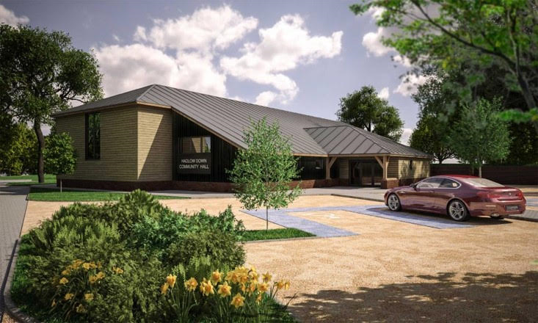

2. A Broader Range of Activities Made Possible
With high-quality, flexible spaces, the new hall will support a much wider and more diverse programme, including:
- Arts, regional theatre and cultural events (up to 200-seat capacity)
- Seasonal markets, exhibitions and community cafés
- Children’s activities, family events and intergenerational programmes
- Yoga, Pilates, dance, wellbeing and fitness classes
- Badminton, pickleball, short mat bowls, martial arts and indoor junior sport
- Youth football training (including for girls), running groups and school sport, supported by modern changing facilities
- Outreach NHS and community clinics – e.g.. Space for allied health professionals who provide diagnostic, preventative, rehabilitative, and therapeutic patient care.
This expanded programme reflects the range of activities residents told us they want through our 2023 community survey.

3. A Step-Change in Local Participation
By providing modern facilities and removing the physical and practical constraints of the current buildings, the new centre will significantly increase participation. It will:
- Provide larger, safer, more welcoming spaces that support more activities and bigger class sizes
- Enable sports and fitness sessions that are currently not possible due to limited space or safety issues
- Offer fully inclusive facilities that older people, disabled residents, families and young people can confidently access
- Allow St Mark’s School, youth teams and community sports clubs to make full use of the grounds and indoor spaces
- Attract new clubs, fitness instructors and cultural groups to operate in the village
4. Summary of Community Benefits
The new community centre will deliver major long-term benefits by:
- Removing the physical barriers that currently prevent many residents from taking part
- Replacing two outdated buildings with one accessible, flexible, future-proofed hub
- Increasing participation in sport, physical activity, arts and culture
- Enabling new programmes such as martial arts, fitness classes and regulated indoor sports
- Supporting families, disabled users and older residents through improved access and parking
- Strengthening community cohesion and social inclusion
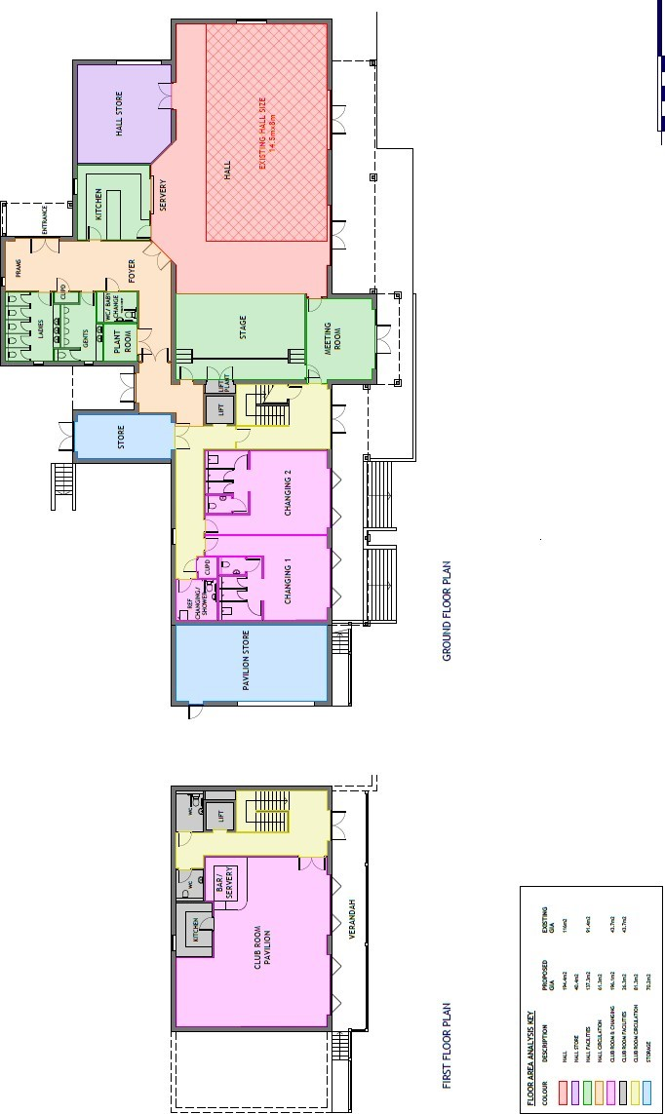
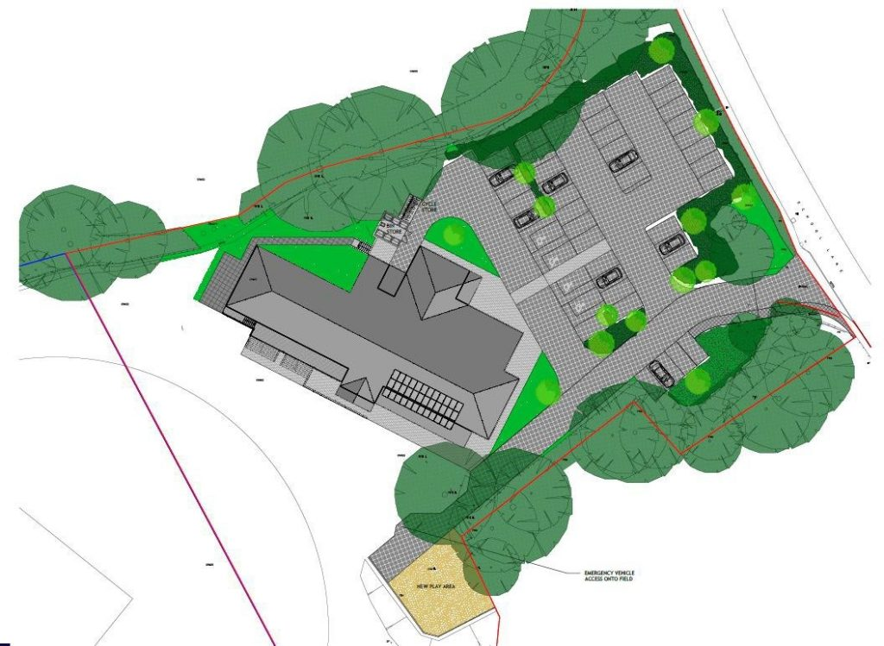

PART 7 FINANCES

1. Capital Costs
This is the estimated cost breakdown of the Phase1 Build (July 2025). We are expecting a further cost of £900k to complete Phase 2 to include changing rooms and sports bar. £440k of this cost will be offset by a VAT rebate on Phase 1.
COST CATEGORY | ESTIMATED COST (£s)
0.0 FACILITATING WORKS | 24,010.00
1.0 SUBSTRUCTURE | 95,237.50
2.1 FRAME | 118,000.00
2.2 UPPER FLOORS | 5,550.00
2.3 ROOF | 199,920.00
2.4 STAIRS & RAMPS | 3,000.00
2.5 EXTERNAL WALLS | 85,950.54
2.6 WINDOWS & EXTERNAL DOORS | 47,100.00
2.7 INTERNAL WALLS & PARTITIONS | 38,199.00
2.8 INTERNAL DOORS | 15,219.24
3.1 WALL FINISHES | 28,480.00
3.2 FLOOR FINISHES | 87,650.00
3.3 CEILING FINISHES | 29,475.00
4.0 FITTINGS, FURNISHINGS & EQUIPMENT | 60,400.00
5.0 SERVICES | 244,387.50
8.0 EXTERNAL WORKS | 497,335.00
9.0 PRELIMINARIES | 221,187.93
SUB TOTAL | 1,801,101.71
10.0 Contractors OH&P @ 10.0% | 180,110.17
TOTAL CONSTRUCTION COSTS | 1,981,211.88
Professional Fees @ 10% | 198,121.19
Contingency @5% | 108,966.65
TOTAL COST (EX VAT) | 2,288,299.72

2. Predicted Operating Cost and Expenditure
From the outset, careful consideration has been given to the need to ensure that once the new hall has been constructed, it can ‘pay its way’, with income received for the use of the facilities exceeding operating and maintenance costs. It should be noted that, being a charity, there is no requirement to have a profit element in its finances, only a need for it to be able to generate sufficient income to pay for the costs of insurance, heating, lighting, cleaning and maintaining the building and external areas, with some monies held in reserve for a ‘rainy day fund’. As a start point, we have looked at the day to day running costs and annual income of both the existing hall and playing field. But additionally, as the new community centre will provide an improved range and quality of facility and will have different running costs, we have also looked at 6 control sites of similar village halls to ensure we make robust assumptions for future income and expenditure of our new centre. Please see detailed Income and Expenditure Assumptions documentation for more detail.

Predicted Surplus Income Over Expenditure (Based on 2024 assumptions)
 | Year 1 | Year 2 | Year 3 | Year 4 | Year 5
Expenditure | 23918 | 24585 | 25829 | 27150 | 28553
Low case Income | 24230 | 25925 | 27749 | 29713 | 31826
High Case Income | 26453 | 30121 | 34339 | 37573 | 41130
Surplus Low | 312 | 1340 | 1920 | 2563 | 3273
Surplus High | 2535 | 5536 | 8510 | 10423 | 12577

We are reassured to see that, even in the Low Case, the new Hadlow Down Community Centre will just breakeven in Year 1 even without grant funding and assuming £2k fundraising and stay in profit moving forwards.
We will look to create a buffer fund as part of our initial fund-raising activities to build the hall, to ensure we have a stable base for the first few years. We will also push up the level of fundraising events and pursue ongoing grant funding to close any gap as we move forward.

Once the new Community Centre is operational, HDCC will generate income through a range of community-focused revenue streams. These will include hire fees for the hall, club room, meeting rooms, workspaces, and kitchen, alongside income from organised activities, classes, events, and community group use. In addition, HDCC will operate a community café, run by volunteers, as an inclusive social hub for residents of all ages. All surplus generated by the café will be reinvested directly into the running costs of the Centre.
In line with our charitable purposes and non-profit status, all income raised by HDCC will be used solely to operate, maintain, and sustain the Community Centre. This includes utilities, cleaning, insurance, planned and reactive maintenance, equipment replacement, staffing/contracted support where necessary, and the creation of prudent reserve funds to ensure the long-term protection of the building and grounds. HDCC will not distribute profit; every pound generated is reinvested to strengthen the Centre, support community activity, and provide a high-quality, accessible facility for the people of Hadlow Down.
Fundraising Plan for 2026
We have carried out extensive research into national and local grant funding organisations and will launch a major grant application drive in 2026 with the help of our professional fundraising advisor and our enthusiastic group of local volunteers to raise the necessary funds. Although we are facing a difficult grant environment, we believe that with seed funding from the Parish and District Councils we will attract the necessary funds. We have already secured £500,000 from the Parish Council and are applying for match funding from Wealden District council.
 | Source | Scheme | Minimum Amount | Maximum Amount | What HDCC might get? | Notes
2025/2026 | National Lottery | Community Lottery Fund | £10,000 | £1,000,000 | £500,000 | For Capital projects, seed funding needed
2025/2026 | National Lottery | Reaching Communities | £10,000 | £500,000 | £300,000 | Only awarded to major capital projects with match funding
2026 | National Lottery | Partnerships and Special Initiatives | £20,000 | £400,000 | £75,000 | Collaboration between community and LAs
2026 | Garfield Weston Foundation |  | £20,000 | £30,000 | £20,000 | For Capital Projects
2026 | Bernard Sunley Foundation |  | £5,000 | £25,000 | £15,000 | Only awarded to major capital projects with match funding
2025/2026 | The Clothworkers Foundation | Community Building projects | £10,000 | £150,000 | £30,000 | Only awarded to major capital projects with match funding
2025 | Grants via East Sussex CC | Local Community Grant Funds | £10,000 | £50,000 | £25,000 | For Capital Projects, requires seed funding
2026 | Energy Redress Scheme | Carbon Emissions Reduction Fund | £50,000 | £2,000,000 | £50,000 | Project must be completed with 2 years, paid quarterly
2026 | Rural England Prosperity Fund | Designed to strengthen community infrastructure | £5,000 | £75,000 | £25,000 | Capital only. Requires match funding
2026 | Comic Relief Community Fund | Community Buildings | £1,000 | £200,000 | £15,000 | Disability/elderly inclusion
2025/2026 | Arts Council, England |  | £1,000 | £100,000 | £2,500 | Only awarded to major capital projects with match funding
2026 | The Trust house Charitable Foundation |  | £2,000 | £10,000 | £2,500 | Community centres or village halls, but only for running costs
2025 | Earnest Kleinwort |  | £10,000 | £20,000 | £15,000 | 4 application windows/year; decisions in ~8–12 week
2026 | Sussex Community Foundation |  | £5,000 | £10,000 | £5,000 | Only awarded to major capital projects with match funding
2026 | DEFRA | Jubilee Village Halls fund | £7,500 | £75,000 | £15,000 | Phase 1 only
2026 | Asda Foundation | Local Community Spaces Fund | £10,000 | £20,000 | £10,000
2026 | B&Q Foundation | Community Spaces | 0 | £10,000 | £10,000 | Buildings Only
Stephen Lloyd Awards | Community/Environmental projects | Accessible community spaces | £2,500 | £10,000 | £3,000 | Indoor and Garden
2026 | Uckfield and Crowborough Chambers of Commerce | Corporate Social Responsibility | £5,000 | £10,000 | £5,000
2026 | Duke of Devonshire Charitable Trust | Community and Environmental Projects | £5,000 | £10,000 | £10,000 | Apply Jan 2026
2026 | Wealden and Hadlow Down Community Lotteries |  | £2,000 | £4,000 | £2,000
2026/2027 | Corporate Sponsorship | Local Business donations and gifts in kind | £30,000 | £50,000 | £30,000
2026/2027 | Crowdfunding |  | £5,000 | £20,000 | £15,000
2025/2026 | Local Fundraising | HDCC | £20,000 | £40,000 | £30,000 | Fundraising Events
2025/2026 | High Net worth Individuals | Benefactors and Supporters | £50,000 | £100,000 | £50,000
2025/2026 | Legacies | Local residents | £20,000 | £10,000 | £10,000 | Will require Legacy campaign
Total |  |  | £326,000 | £5,039,000 | £1,270,000

PART 8 MANAGEMENT AND ORGANISATION

1. Management Structure
The Hadlow Down Community Centre (HDCC) is a registered Charitable Incorporated Organisation (CIO) established to plan, construct, own and operate the new Community Centre on the Hadlow Down Playing Field. As a CIO, HDCC has its own legal identity and provides limited liability for trustees, offering a transparent and resilient governance structure for managing a long-term community asset.
HDCC holds a 99-year lease on the development site, giving it full authority to design, build, occupy and manage the new facility for charitable and community purposes. On completion, the CIO will be the legal owner and custodian of the Centre and will be responsible for insurance, compliance, health and safety, maintenance and the effective delivery of community activities.
The organisation is governed by a Board of Trustees who provide overall strategic leadership. They will ensure the Centre is managed in line with its charitable objectives, oversee finances and organisational risk, set operational policies and safeguard public benefit. Day-to-day activities, maintenance and community programming will be delivered by volunteers and contracted staff where required. We anticipate needing a centre manager, care taker and cleaner as currently used by the existing village hall.
Governance is further strengthened by a joint advisory group comprising HDCC trustees, Hadlow Down Playing Field (HDPF) trustees and Parish Council representatives. Meeting every six weeks, this group provides coordinated oversight of planning, risk management, funding, business planning and project delivery, ensuring accountability and alignment with wider village priorities.

2. Partnerships
Delivery and long-term operation of the Community Centre rely on strong collaboration with a wide network of partners:
- Hadlow Down Playing Field – close cooperation to deliver a high-quality sports, recreation and arts facility serving the village and wider area.
- Parish Council – regular updates on progress, planning, budgets and fundraising, ensuring alignment with local priorities.
- Advisory Committee – strategic guidance on governance, risk management and operational planning.
- Wealden District Council – liaison and reporting to meet grant conditions, ensure transparency and align with CLIF objectives.
- AIRS (Action in Rural Sussex) – support on best practice in governance, sustainability and inclusive community engagement.
- Architects and Engineers – ensuring the building meets modern construction, accessibility, energy-efficiency and low-carbon standards.
- Professional Fundraiser (Jules Sherwood) – guidance on grant applications, donor engagement and achieving capital fundraising targets.
- Local Businesses – opportunities for procurement, sponsorship and service partnerships, strengthening both the project and the local economy.
- Neighbouring Parish Councils and Community Groups – engagement to encourage regional use of the new facility.
- Local Volunteers – supporting events, fundraising and operational activity, reinforcing community ownership.
- Mentors from Five Ashes – sharing learning on governance, operations and income generation from a comparable rural hall.
- Hall Users – ongoing consultation on design, facilities, pricing and programming to ensure the Centre meets diverse needs.
- Sport England (Movement Fund) – support for sport and recreational activities such as dance, martial arts, table tennis, bowls and badminton.
- Active Sussex – partnership focusing on increasing activity levels among children, older people, disabled residents and those with long-term health conditions.
- Arts Council England (South East) – guidance and potential funding to support cultural participation including dance and theatre.
- National Lottery Community Fund – Reaching Communities – potential support for community-led programmes and inclusive participation.
Through this coordinated partnership approach, the new Community Centre will remain community-led, inclusive and financially and environmentally sustainable, ensuring it becomes a well-used and resilient asset for the long term.

PART 9 MARKETING

The opportunities presented by the new hall will be extensively publicised well before completion, so hirers are signed up as soon as the facilities are completed. This will be by means of:
- A word-of-mouth campaign to spread the good news of our project so far and our hopes for the future. We feel that, in a small community, the strength of word-of-mouth communication in the school, church or pub cannot be underestimated
- Parish and community notice boards
- Church display notice boards
- Posters/notices displayed in Village Pub/Wilderness Wood Hub/ Primary School
- Ongoing articles in Hadlow Down Village Magazine, a monthly magazine containing Hadlow Down news and events. Distributed by volunteers to all houses in the village
- News articles posted on the Village Website and on our already well established HDCC website www.newvillagehall.co.uk
- The Hall will be advertised in the neighbouring parishes where there are currently no community hall facilities.
- Letters will be sent to local business owners inviting them to walk through the new facilities and strengthen and build partnerships. We will reach out to the 26 new Business park tenants at Five Chimneys Business Park on Curtains Hill. The Hall is perfectly positioned to provide facilities for both recruitment and training events.
- The Committee room will provide an opportunity to hot desk during the day, this will be advertised in the village and offered to residents at preferential rates.

Our publicity in surrounding villages will be aimed specifically at attracting individuals and groups to use the new facilities which will be available in the new village hall and sports pavilion.

PART 10 ENVIRONMENTAL IMPACT

Our proposal to build a sustainable and inclusive Community Centre in Hadlow Down will make a significant contribution to Wealden District Council’s strategic objectives for climate change, environmental protection, community resilience, and wellbeing. Designed around principles of sustainability, inclusion, and local resilience, the centre will serve as both a practical and symbolic example of how rural communities can lead the transition to a low-carbon future.
The new community centre will demonstrate leadership in responding to the climate emergency declared in 2019 by Wealden District Council. Through its energy-efficient, low-carbon design, the project will reduce emissions during both construction and operation. Sustainable building materials, local sourcing, and efficient insulation will minimise embodied carbon, while renewable energy systems—such as solar panels and air-source heat pumps—will enable the building to operate with minimal reliance on fossil fuels. By incorporating natural ventilation, daylighting, and passive heating, the centre will set a new local standard for sustainable design. It could also act as an educational hub, hosting workshops and exhibitions on home energy efficiency, recycling, and carbon reduction, thereby inspiring behavioural change within the wider community.
Aligned with the Council’s environmental priorities, the project will enhance the ecological value of the site and promote stewardship of the natural environment. Landscaping will prioritise native planting, biodiversity corridors, and pollinator-friendly habitats, contributing to Wealden’s biodiversity action goals. Sustainable drainage, rainwater harvesting, and on-site composting will reduce water use and waste. The outdoor spaces will function as a “living classroom,” supporting environmental learning for local schools and community groups. In doing so, the centre will serve as a model of responsible land use and nature-positive development.

PART 11 MONITORING AND EVALUATION

A structured monitoring and evaluation framework will ensure the Hadlow Down Community Centre delivers strong community, environmental and financial outcomes, demonstrating effective and responsible use of grant funding.
1. Pre-Completion Monitoring
During construction, trustees will receive monthly updates on programme progress, budget performance and risk management. Fundraising progress will be tracked against capital targets to ensure sufficient resources for both construction and early operation. Fundraising efforts will be supported by a visible fundraising tracker displayed at the site, helping the community follow progress and maintain momentum. All procurement will follow competitive tendering and contract oversight to ensure value for money, and regular site checks will confirm that quality, accessibility and sustainability standards are met before handover.
2. Post-Completion Financial and Operational Performance
Following opening, quarterly and annual reviews will assess operating costs, income generation and progress towards break-even (expected in Years 2). Maintenance obligations and reserve fund targets will be monitored to ensure long-term financial robustness and effective asset management.
3. Environmental Sustainability Outcomes
The centre’s environmental performance will be monitored through energy use, carbon footprint, renewable system outputs, water efficiency and waste reduction. Biodiversity improvements on site will also be reviewed annually to ensure environmental commitments are met.
4. Social and Community Impact
Community benefits will be assessed through levels of hall usage, the range and diversity of activities offered, demographic reach (including young people, older residents and disabled users), attendance at events and satisfaction levels captured through surveys. Volunteer involvement and new partnerships will provide further evidence of social impact and community engagement.
5. Governance, Management and Long-Term Resilience
Trustees will undertake quarterly governance reviews, covering finance, risk, safeguarding and policy compliance. Routine building inspections and a rolling five-year maintenance plan will support asset longevity, while staff performance reviews and benchmarking against comparable rural halls will help maintain high operational standards.
6. Reporting and Transparency
An Annual Impact & Performance Report will be submitted to funders, supported by interim updates during construction and early operation. Reporting will clearly link expenditure to grant conditions and provide evidence of usage, environmental performance and community outcomes. Public summaries will be made available on the centre’s website and at the AGM to ensure openness and accountability.
7. Promoting Success and Ongoing Engagement
Successes and developments will be shared through newsletters, social media, the website and local noticeboards. Open days, taster sessions and community workshops will help attract new users, while case studies and updates on fundraising achievements will reinforce community support and demonstrate the centre’s value.

PART 12 THE ACTION PLAN

We have developed a comprehensive five-year delivery plan (submitted separately) with input from our professional advisors and Hadlow Down Parish Council. This plan outlines the key activities required across all workstreams—Lease, Governance, Fundraising, Marketing and Communication, and Design and Build—and sets out the critical path and interdependencies needed to ensure successful delivery.

Our delivery timeline is as follows:
2025: Finalise and sign the long-term lease; strengthen governance structures; formalise project documentation; secure support from Hadlow Down Parish Council and Wealden District Council for seed funding.
2026: Deliver a major fundraising campaign, prioritising large funders aligned with our strategy and funding cycles, followed by medium-sized grant makers and local benefactors.
2027: Appoint a construction project manager, undertake a full tender process for contractors and suppliers, and commence construction by September 2027. Concurrently, begin targeted fundraising for Phase 2 (changing facilities and sports bar).
2028: Complete construction; transition operations from existing facilities to the new centre; implement operational and staffing plans.
2029: Achieve full operation and community use of the new centre.

Key delivery components
1. Lease: We are in the final stages of securing a new 99-year lease for the building footprint and car park. Drafts have been exchanged between solicitors, and signing is expected imminently, providing long-term security required for major capital investment.
2. Governance: We operate under a strengthened governance model with oversight from a joint advisory group comprising HDCC trustees, HDPF trustees, and Parish Council representatives. This structure ensures robust planning, clear accountability, and coordination with wider village stakeholders. The group meets every six weeks and has driven the development of all core project documents, including the risk log, funding framework, business plan, and detailed delivery plan.
3. Fundraising: Supported by a professional fundraising advisor, we have a clear and phased fundraising strategy, beginning with securing approximately £1 million in seed funding from Parish and District grants. A major grant application programme will be launched in early 2026, targeting national and regional funders as well as local benefactors. Our goal is to raise at least £750k in grants by the end of 2026 and then secure the remaining £250k locally to fully fund Phase 1, followed by additional fundraising for Phase 2.
4. Marketing & Communication: We have an established communications plan to ensure continued engagement with residents, clubs, societies, and other stakeholders. This includes regular updates via the website, village Facebook page, and village magazine, as well as door-to-door information for major milestones (as recently carried out for the Parish Poll).
5. Design and Build: Once funding is confirmed, we will initiate a structured tendering process overseen by an experienced project manager. The construction phase is expected to take up to 15 months. All procurement and delivery will follow best-practice project management principles to ensure value for money, quality, and timely completion.
This coordinated and professionally supported approach ensures the project is both deliverable and sustainable, with clear accountability, realistic timelines, and strong community backing.

Part 13 SUMMARY

The Hadlow Down Community Centre project represents a once-in-a-generation opportunity to secure the long-term social, cultural, recreational and environmental wellbeing of our rural community. After more than a decade of planning, consultation and refinement, the case for investment is clear and grounded in strong evidence of community need, deteriorating existing facilities and a shared ambition for a modern, inclusive and sustainable space that serves all residents. With full planning permission secured, a 99-year lease in place and a strengthened governance structure involving HDCC trustees, the Playing Field Association and the Parish Council, the project is now well positioned to move forward.

The new centre will provide accessible, multi-functional spaces capable of hosting a wide range of activities—from sport and wellbeing programmes to arts, education, youth activities and community events—removing long-standing barriers to participation and offering significant benefits to Hadlow Down and its neighbouring villages. Financial modelling shows the centre will be operationally sustainable, achieving break-even in its second year with increasing surpluses thereafter, all of which will be reinvested into maintaining and enhancing the facility for future generations. Designed with environmental responsibility at its core, the building will use low-carbon technologies, efficient construction methods and biodiversity-enhancing landscaping to meet modern sustainability expectations.
This business plan demonstrates that the project is not only desirable but essential to the village’s long-term resilience and quality of life. With strong community support, clear delivery plans and a vision centred on inclusion, wellbeing and connection, Hadlow Down is ready to create a thriving, future-proofed community hub that will serve generations to come.

